Prepared by:

[ .: www.bios-pro.mk :. ]
RESETTLEMENT AUDIT
LOCAL ROADS CONNECTIVITY PROJECT

Municipality of Kichevo

RECONSTRUCTION OF BORIS KIDRICH STREET

June, 2022
Table of Contents
Abbreviations 2
Executive Summary 3
1. Introduction 4
2. Project description 4
3. Audit Methodology and Objectives 6
3.1. Terms and Objectives of the Resettlement Audit 6
3.2. Audit Methodology 7
4. Findings of the Resettlement Audit 8
4.1. Resettlement Events 8
4.2. Project Affected Parties 9
4.3. Resettlement related Impacts 9
4.4. Communication with the affected parties 10
4.5. Identified Gaps 10
4.6. Eligibility and Entitlements Matrix 11
4.7. Incurred loss 11
4.8. Grievance Redress Mechanism 12
5. Conclusion and Recommendations 12
5.1. Mitigation measures 12
5.2. Implementation Arrangements 13
5.3. Monitoring and Reporting 13
6. Budget for compensation 14
ANNEXES 16
Annex 1: Announced Procurement for Resettlement Audit 17
Annex 2: Announced Decision on Procurement for Resettlement Audit 20
Annex 3: Ascertainment for determining the condition of temporary facilities that do not perform activities 22
Annex 4: List of online sources of relevant information for this RA 23
Annex 5: Agreement/Consent to be offered by the Municipality for compensation of affected parties 24
Annex 6: Grievance Redress Form 26
Annex 7: List of contact information of the affected individuals 27
Annex 8: Image of dislocation of object 5 by the company owner 28
Annex 9: Image of new location of object 8 29

Abbreviations

Abbreviation | Meaning
E&S | Environmental and Social
ESS | Environmental and Social Standards
ESMF | Environmental and Social Management Framework
ESMP | Environmental and Social Management Plan
EUR | Euro
GNM | Government of North Macedonia
GRM | Grievance Redress Mechanism
IBRD | International Bank for Reconstruction and Development
LRCP | Local Roads Connectivity Project
MKD | Makedonski Denar
MoK | Municipality of Kichevo
MoTC | Ministry of Transport and Communication
PAP | Project Affected Persons
PIU | Project Implementation Unit
RA | Resettlement Audit
RPF | Resettlement Policy Framework
WB | World Bank

Executive Summary

The Government of North Macedonia (GNM) intends to receive a loan from the International Bank for Reconstruction and Development (IBRD) World Bank for the implementation of the Social Services Improvement Project. The Project is to be implemented by the Ministry of Transport and Communication of the Republic of North Macedonia and will support improvement of local roads and its connectivity.
World Bank’s Environmental and Social Standard 5 (Land Acquisition, Restrictions on Land Use and Involuntary Resettlement) is the standard guiding land acquisition and related resettlement/compensation issues during project implementation.
Displacement activities conducted on the street Boris Kidrich in Kichevo is assumed that affected 23 people and 2 businesses. Some of them are eligible for compensation.

Introduction
This document is Resettlement Audit (RA), and it was developed by BIOS PRO, dooel Skopje on request of the Municipality of Kichevo (MoK) from the Republic of North Macedonia (hereinafter referred to as “Investor”), in order to give overview on the process of resettlement that was conducted as a part of the constitution activities performed during Reconstruction of Boris Kidrich Street, located in the city of Kichevo.
The constitution activities during Reconstructing the Boris Kidrich Street, located in the city of Kichevo, are part of the Local Roads Connectivity Project (LRCP) of the Ministry of Transport and Communication (MoTC). This project is financially supported by the World Bank (contract signed with the MoTC in November 2019), who has been guided by its Environmental and Social Framework and its 10 Environmental and Social Standards (ESS). Environmental and Social Standard 5 (Land Acquisition, Restrictions on Land Use and Involuntary Resettlement) is the standard that is guiding the land acquisition and related resettlement/compensation process and issues during project implementation.

Project description
At the Ministry of Transport and Communication, under the Project for Connecting Local Roads (financially supported World Bank) the Municipality of Kichevo applied with three sub-projects:
- Reconstruction of the street Boris Kidrich;
- Reconstruction of street Uzichka Republika and
- Reconstruction of local road from village Greshnica to village Dlapkin Dol.
The contract for LRCP project with the World Bank – International Bank for Reconstruction and Development (9034-MK) is signed in November 2019.
The official letter from MoK to MoTC for applying for financing the construction activities on the above-mentioned sub-projects, was received by the Ministry of Transport and Communication on September 18th, 2020, prior to signed Memorandum for understanding on 28.02.2020 between MoK and MoTC. The contract for implementation with the Ministry of Transport and Communication was signed 14.09.2021/24.09.2021.
For the purpose of successful realization of project activities, Municipality of Kichevo initiated a process of clearance of the area needed for realization of the planned project activities. Construction activities and civil works started in 2020, and in 2021 the Municipality of Kichevo undertook activities to dislocate the existing kiosks/shops, whose operational permit expired several years ago, located on two locations on the same street Boris Kidrich:
- Location A – next to the primary school Kuzman Josifovski Pitu
- Location B – in front of the Real Estate Cadaster’s office (branch Kichevo) and Municipality’s premises.
The location of the kiosks in their initial position, recorded by the Real Estate Cadaster register is presented on the images below.

Location A (13 objects)
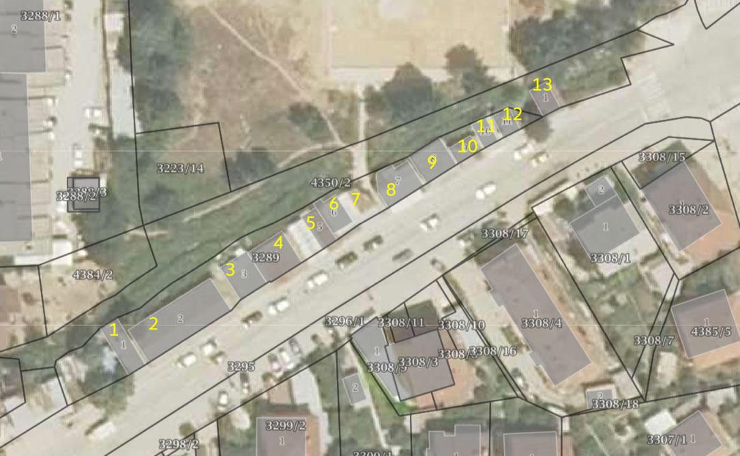
Location B (11 objects)
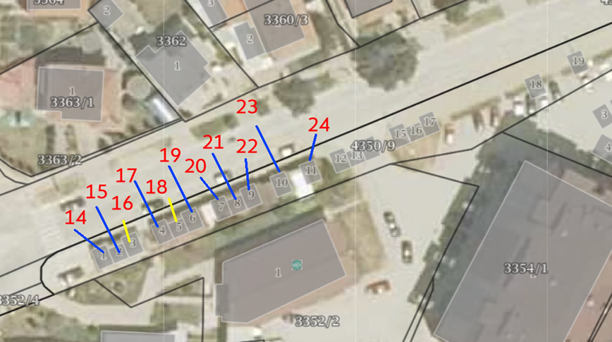
The following images show the current state of the Boris Kidrich Street, near the location A.
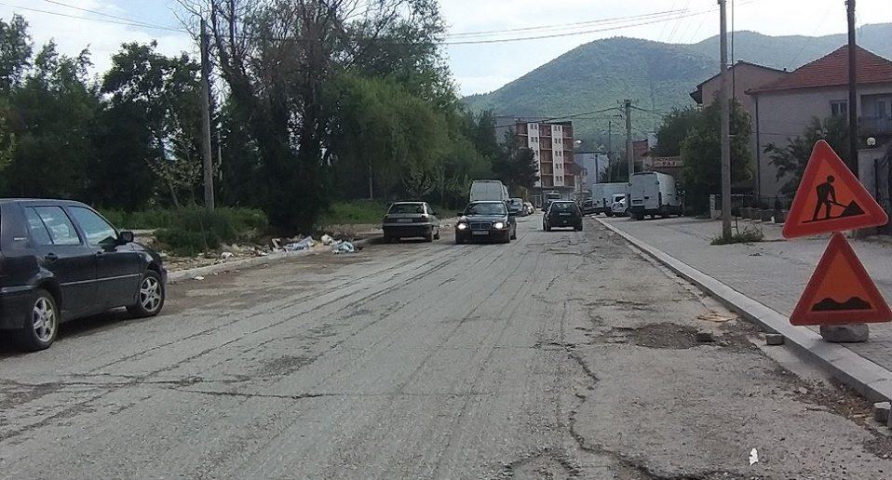
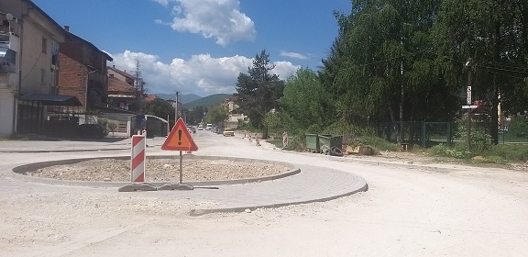
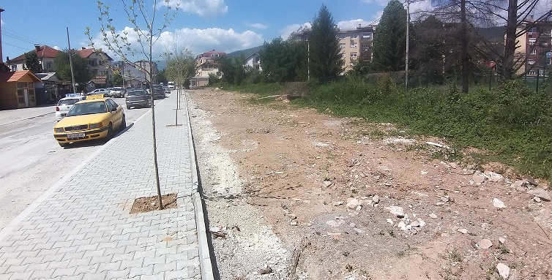

Audit Methodology and Objectives

Terms and Objectives of the Resettlement Audit
The overall objective of this Resettlement Audit is to understand:
- the extent to which the sub-project performed on the Boris Kidrich Street complied with the WB ESF, and particularly with ESS5 and ESS10; and
- recommend gap filling measures also in relation to the new ESF requirements, especially ESS5 and ESS10.
Specific objectives of this audit activities are:
- Identify the owners/users of demolished objects on the Boris Kidrich Street
- Create list of objects and description of the economic activity performed in them
- Identify which of the object was in function at the time of displacement
- Identify which business is transferred to another location and it is still active
- Identify real cause real business closure of affected business objects
The activities covered under this document include, but are not limited to, the following tasks:
- Gathering relevant and reliable information on the scope of resettlement in order to determine its extent;
- Consulting/Interviewing affected business and premises owners regarding resettlement event;
- Determining the incurred costs conducted regarding resettlement;
- Determining the incurred damage to material assets (valuation of assets lost is excluded);
- Determining the losses in livelihood or decrease in income due to the displacement;
- Determining the eligibility in compliance with WB ESF and its E&S Standards (2018) for compensation and method for approaching affected persons.

Audit Methodology
The Resettlement Audit was carried out by an independent third party, BIOS PRO, dooel Skopje upon request by the Municipality of Kichevo (MoK). BIOS PRO performed RA related activities in the period middle to late May and early June 2022 with assistance from the MoK, and sincere cooperation by affected individuals.
The process of selection of the company that will conduct the Resettlement Audit followed the national Procurement procedure, and MoK announces procurement on the specialized website www.e-nabavki.gov.mk, on May 03, 2022 (see Annex 1). Mayor of MoK issues Decision for selection of best offer No. 09 - 1312/3, from 16.05.2022, where BIOS PRO is selected as the best offer (see Annex 2). After signing the contract on 27.05.2022, BIOS PRO develops methodology framework for conducting planned RA.
Methodology framework included:
- Process of information gathering and its validation
- Process of information analysis
The process of information gathering included obtaining data from relevant and reliable sources, and included cooperation with MoK, affected people and local population living in the very vicinity of the affected location.
MoK provided significant relevant information, some dated from 1989. The complete list of documents provided by the MoK. Also, information from reliable internet sources was used (see Annex 4) for the demolition of the remaining of the ruined objects.
Official online sources are also considered MoTC website where the ESMP checklist was published both in Macedonian and English language. Furthermore, relevant ownership information of the affected objects was used, from the free online data Real Estate Cadastral Office.
At last, interviews in person and phone with the affected parties (both users and owners) were conducted in the period 17.05.2022 – 08.06.2022, and most of the respondents shared their purchase contracts and other relevant data.
During the process of information gathering the team of interviewer and researcher didn’t manage to contact all affected parties due to the objective (death, migration abroad, change of residence) and personal (refusal for cooperation due to unknown reasons,) reasons.
Data analysis included process of reviewing and comparing the gathered information in order to organize it in adequate chronological order. Images taken from the site visits (17.05.2022, 23.05.2022 and 06.06.2022) along with the graphics provided by the MoK and available online were processed and used to create realistic impression of the project area prior, during and after process of demolition of the kiosks/objects.
It is worth to mention that this RA follows the provisions set in the relevant Project documentation, particularly the document named Resettlement Policy Framework which is basic document that defines terms and conditions how the municipalities to react in case some of its subproject faces resettlement issues, regardless it is word about physical or economic displacement.

Findings of the Resettlement Audit

Resettlement Events
Prior to the act of demolition, MoK in July 2014 prepared Record of Constatation and issued Decision for Object Removal for all kiosks set on both location A and B. But only objects that were impeding the construction of residential building and entrance to the construction location (later parking) in 2014, located on the location B, near the MoK, were removed. In total, with the first wave only 6 objects were removed immediately, while the remaining of the 11 objects at the location B, and 13 at the location A, were cleared in 2021.
Upon recording the situation with the objects on 18.01.2021, the MoK issued Ascertainment for determining the condition of temporary facilities that do not perform activities on the Boris Kidrich Street (09_117/1 from 18.01.2021) where it registers all empty and abandoned objects along the street (see Annex 3).
There were three clearance/dismantling periods in 2021. For the location B it was period starting from 16.07.2021 till end of the month, and for the location A these periods were end of (25) August and middle of October 2021.
For the objects on location B, letters to the owners requiring to demolish/dismantle their objects by themselves, were sent to the registered owners of the remaining objects dated on 12.07.2021, while for the location A letters sent to the registered owners of the remaining objects were dated 24.02.2020, 12.03.2020 and 21.04.2022. In addition to this, online media provided public information for the forthcoming act of demolition on both locations, as well as information for conducted demolition and dislocation of materials on location B. For the location A, owners and tenants were verbally informed (21 May 2021) that the objects have be demolished/ dismantled in a very due time.
For the objects set on location A, the owners demolished/dismantled the object and took materials from their object that they thought it was usable (interior and metal), while the remaining materials (along with the debris) was removed by the municipality to the designated location. Only the object that was a governmental property, was demolished by the municipality in total.
At the location B, the municipality dismantled only three abandoned and semi-ruined objects, that belong to those owners who didn’t show on site to demolish/dismantle own premises and took/extract the metal, interior and other materials personally.

Project Affected Parties
Displacement activities conducted on the street Boris Kidrich in Kichevo directly affected 15 private individuals of which 5 have active businesses. The following table gives overview of the project affected parties directly influenced by the act of displacement / demolition of the business located in the outdated business premises set along the Boris Kidrich Street.
Table 1 Affected people and Businesses
PAP's code | Name and Surname of PAP | Object number | Status | Business prior displacement
P01 |  | 1 | Owner
P02 |  | 2 | Owner
P03 |  | 3 | Owner
P04 |  | 3 | Tenant
P05 |  | 4 | Owner
P06 |  | 5 | Owner
P07 |  | 6 | Tenant
P08 |  | 6 | Owner
P09 |  | 7 | Owner
P10 |  | 8 | Owner
P11 |  | 9 | Owner
P12 |  | 10 | Owner
P13 |  | 11 | Owner
P14 |  | 12 | Owner
P15 |  | 13 | Owner
P16 |  | 14 | Owner
P17 |  | 15 | Owner
P18 |  | 16 | Owner
P19 |  | 17 | Owner
P20 |  | 18-19 | Owner
P21 |  | 20 | Owner
P22 |  | 21 | Owner
P23 |  | 22 | Owner
P24 |  | 23 | Owner
P25 |  | 24 | Owner

Resettlement related Impacts
Detail findings regarding different property owners and tenants can be found on the following Table.
Table 2 Details on affected people and businesses
PAP's code | Details
P01
P02
P03
P04
P05
P06
P07
P08
P09
P10
P11
P12
P13
P14
P15
P16
P17
P18
P19
P20
P21
P22
P23
P24
P25

Communication with the affected parties
Four businesses, still all active and previously located on location A, have been contacted in person (except XXXXXXXXXXXX, that has several owners, but nobody responded to calls). Those, who have closed their business prior to the dismantling of the objects and clearance of both locations A & B, have been contacted by phone (See annex 7). About the person who moved abroad, we got information from the interviewed owners and users of the objects at the location A. In addition to this, his house was visited and shutters on the windows were closed for a sensible period of time. His telephone number, that we obtained from our interviewees in person, was not reachable.
Only four people from the location B were contacted by phone, of which 2 refused to communicate and cooperate, while for the remaining affected from the location B it was not possible to obtain contact information from other PAP at the location B that were interviewed.

Identified Gaps
The ESMP document holds information regarding grievance redress mechanism, but strongly lacks site specific data that will explain the social setting and business performed on the edge of the street (those who use the street, and consequently some affected by this project).
No Resettlement Plan has been conducted, although some of the activities were already described in the technical part of the project design.
MoK wasn’t aware of the World Bank and its valid Environmental and Social Framework’s ESS.

Eligibility and Entitlements Matrix

Table 3 Entitlement and Compensation Matrix
Asset Acquired | Type of impact/Risk | Entitled person | Compensation entitlement
Commercial property | Loss of business and/or rent | PAP (owner, tenant or squatter) | Compensation for loss of income incurred as a result of relocation including any discrepancies in livelihood. Support to reestablish the business in other suitable location.
Livelihood  (Loss of job or non-agricultural income) | Loss of income from employment | Employees | Affected employees will receive assistance for temporary loss of wages and, if necessary, assistance in identifying alternative employment opportunities;

Incurred loss
The following table indicates the loss occurred due to the dismantling of the objects.

Table 4 Incurred losses due to the Rehabilitation of the Boris Kidrich Street project
PAP's code | Decrease in livelihood | Dismantling and transport of materials | Increased operational costs
P01 | - | - | -
P02 | - | - | -
P03 | ✓ | ✓ | -
P04 | - | ✓ | -
P05 | - | ✓ | -
P06 | - | ✓ | -
P07 | - | ✓ | ✓
P08 | - | ✓ | -
P09 | - | ✓ | -
P10 | - | ✓ | ✓
P11 | - | ✓ | -
P12 | - | ✓ | -
P13 | ✓ | ✓ | ✓
P14 | - | ✓ | -
P15 | - | - | -
P16 | - | ✓ | -
P17 | - | - | -
P18 | - | ✓ | -
P19 | - | ✓ | -
P20 | - | - | -
P21 | - | - | -
P22 | - | - | -
P23 | - | - | -
P24 | - | - | -
P25 | - | - | -

Grievance Redress Mechanism
Grievance form was not available online, although there was a dedicated page within the official municipality’s website that explain the existence of ESMP, grievance mechanism and form and ESMP checklist. Both pages explain the GRM, but it seems that the GRM was not uploaded/set available for downloading by the website visitors.
However, the grievance redress form is given in Annex 6 and it can be sent to Project developer and sub-project beneficiary, who will forward it to the PIU and MoTC, and try to resolve it in a due time, as per approved RPF for LRCP.

Conclusion and Recommendations

Mitigation measures
It is advisable, MoK to compensate the loss of:
- Income and livelihood
- Activity of demolition / dismantling
- Activity for collecting debris
- Property loss
- Increased operational costs
It is also suggested Ministry for Transport and Communication to financially and logistically support the Municipality of Kichevo in compensation of the aggrieved parties identified in this document. MoK is limited in legal terms to secure funds that might be needed for the purpose of compensation.
The following table presents guidance for compensating the affected parties.
Table 5 Proposed compensation costs
 | Proposed items for compensation | Monthly (EUR) | Maximum frequency
A | Employment assistance - Cost occurring for employment during inactive period, such as taxes for employment (minimal salary 18.000 MKD = costs are ca. half the salary)
B | Dismantling the object and debris clearance, per worker
C | Transport of debris and materials do designated location
D | Business premises rent assistance
E | Lost livelihood/income

The following table indicates the loss occurred due to the dismantling of the objects.

Table 6 Compensation frequency in compliance with Table 5 (A-E)

PAP's code | A | B | C | D | E
P01 | - | - | - | - | -
P02 | - | - | - | - | -
P03 | - | 2 | 2 | - | 1
P04 | - | - | 2 | - | -
P05 | - | 4 | 2 | - | -
P06 | - | 2 | 2 | - | -
P07 | 1 | - | 2 | 1 | -
P08 | - | 2 | 2 | - | -
P09 | - | 2 | 2 | - | -
P10 | 3 | 2 | 2 | 3 | -
P11 | - | - | 2 | - | -
P12 | - | - | 2 | - | -
P13 | 3 | 2 | 2 | 3 | -
P14 | - | 2 | 2 | - | -
P15 | - | - | - | - | -
P16 | - | - | 2 | - | -
P17 | - | - | - | - | -
P18 | - | 2 | 2 | - | -
P19 | - | - | 2 | - | -
P20 | - | - | - | - | -
P21 | - | - | - | - | -
P22 | - | - | - | - | -
P23 | - | - | - | - | -
P24 | - | - | - | - | -
P25 | - | - | - | - | -

Implementation Arrangements
MoK will invite affected persons to offer them compensation for incurred costs in June 2022, as per table 7 below. Agreement/Consent (see Annex 5) will be signed between the Municipality and affected parties eligible for compensation (see tables 1, 5, 6 and 7) and the MoK will disburse the compensation to their transaction account. In case of absence of owners/tenants, the money will be deposited to an escrow account of the municipality.

Monitoring and Reporting
PIU will monitor the successfulness of completion of the resettlement process by collecting official information for two indicators:
- Signed CONSENT (Annex 5) by each affected person, or at least those who didn’t migrated abroad
- Disbursed compensation to the Transaction Account of the affected parties (Table7)
MoK will report to the MoTC on a weekly basis on the progress in communication with the affected parties (1-25).
MoK must provide material evidence that placed efforts to communicate those who didn’t respond to the call for signing agreement.
In case some of the affected parties refuses to be compensated or considers the offered compensation insufficient should use the provisions for mediation and resolution of disputes set in RPF, and PIU should get involved in consideration of the reasons and finding solution to the occurred dispute.

Budget for compensation
Proposed compensation to be disbursed to the affected parties, in accordance with the entitlement matrix, Table 6 and RPF is as follows:
Table 7 Planned compensation for losses incurred due to the Rehabilitation of Boris Kidrich Street

PAP's code | Table 6 - A -  (EUR) | Table 6  - B -  (EUR) | Table 6  - C -  (EUR) | Table 6  - D –  (EUR) | Table 6  - E –  (EUR) | Total for compensation  (EUR)
P01
P02
P03
P04
P05
P06
P07
P08
P09
P10
P11
P12
P13
P14
P15
P16
P17
P18
P19
P20
P21
P22
P23
P24
P25
TOTAL:

ANNEXES

Annex 1: Announced Procurement for Resettlement Audit
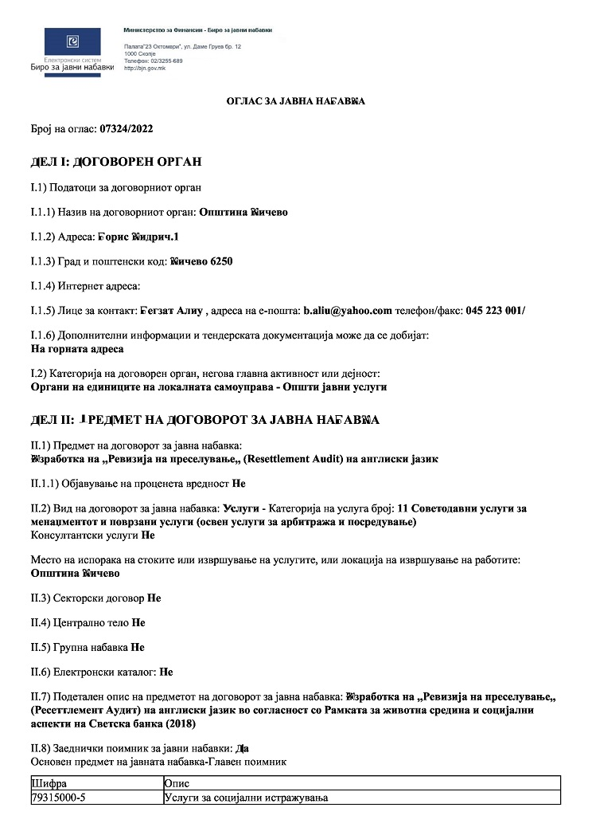
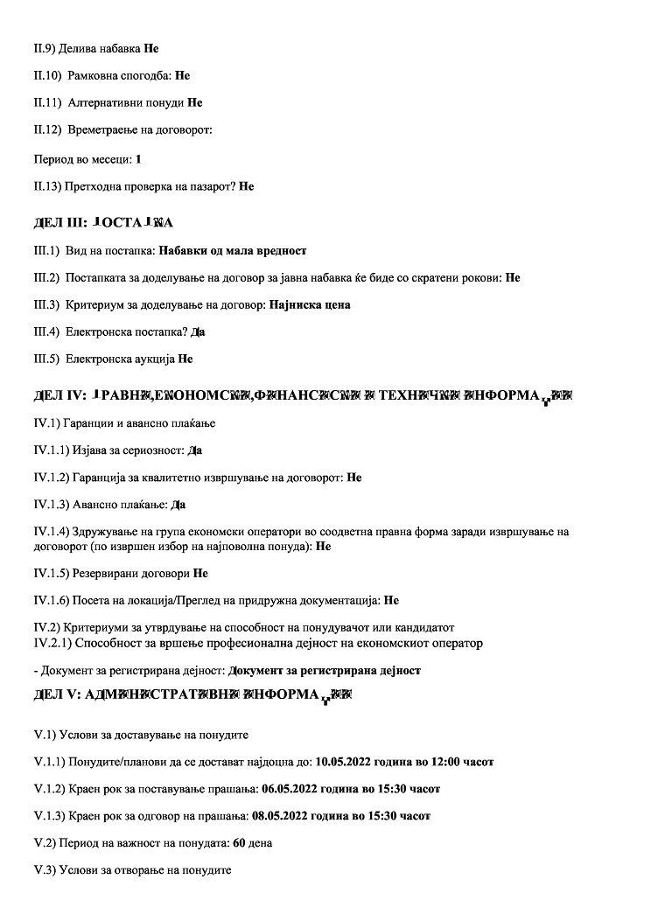
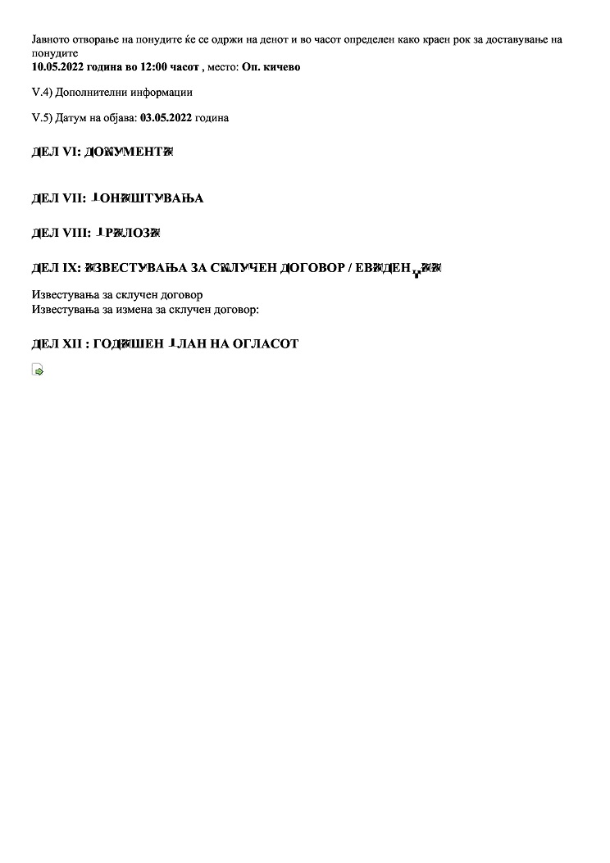

Annex 2: Announced Decision on Procurement for Resettlement Audit
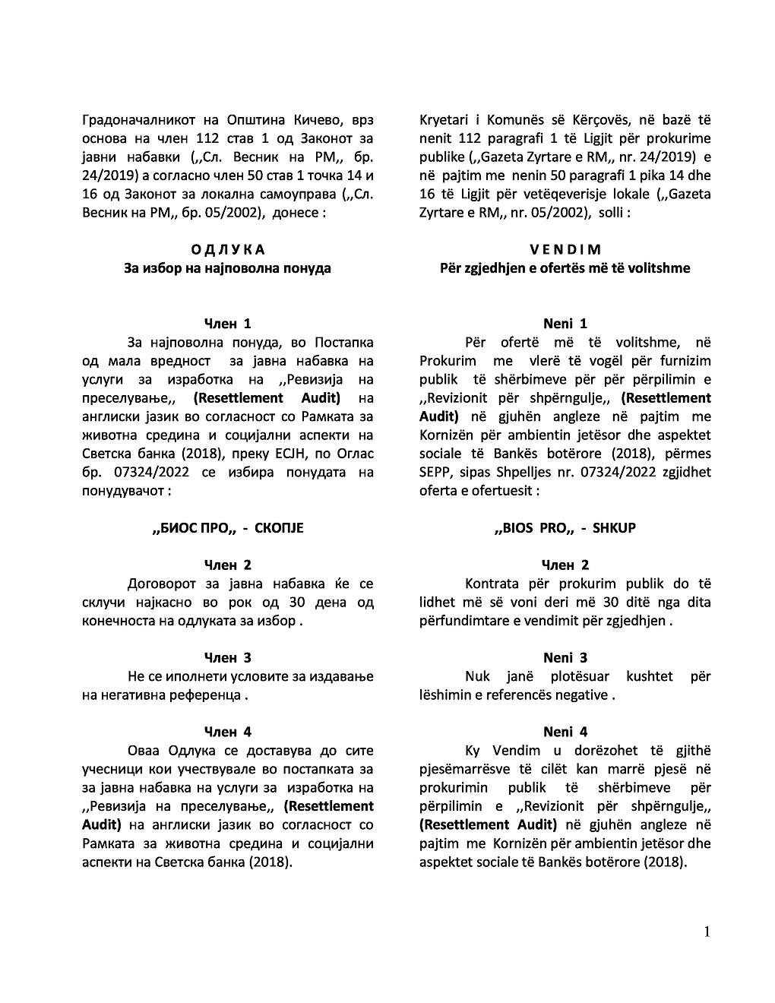
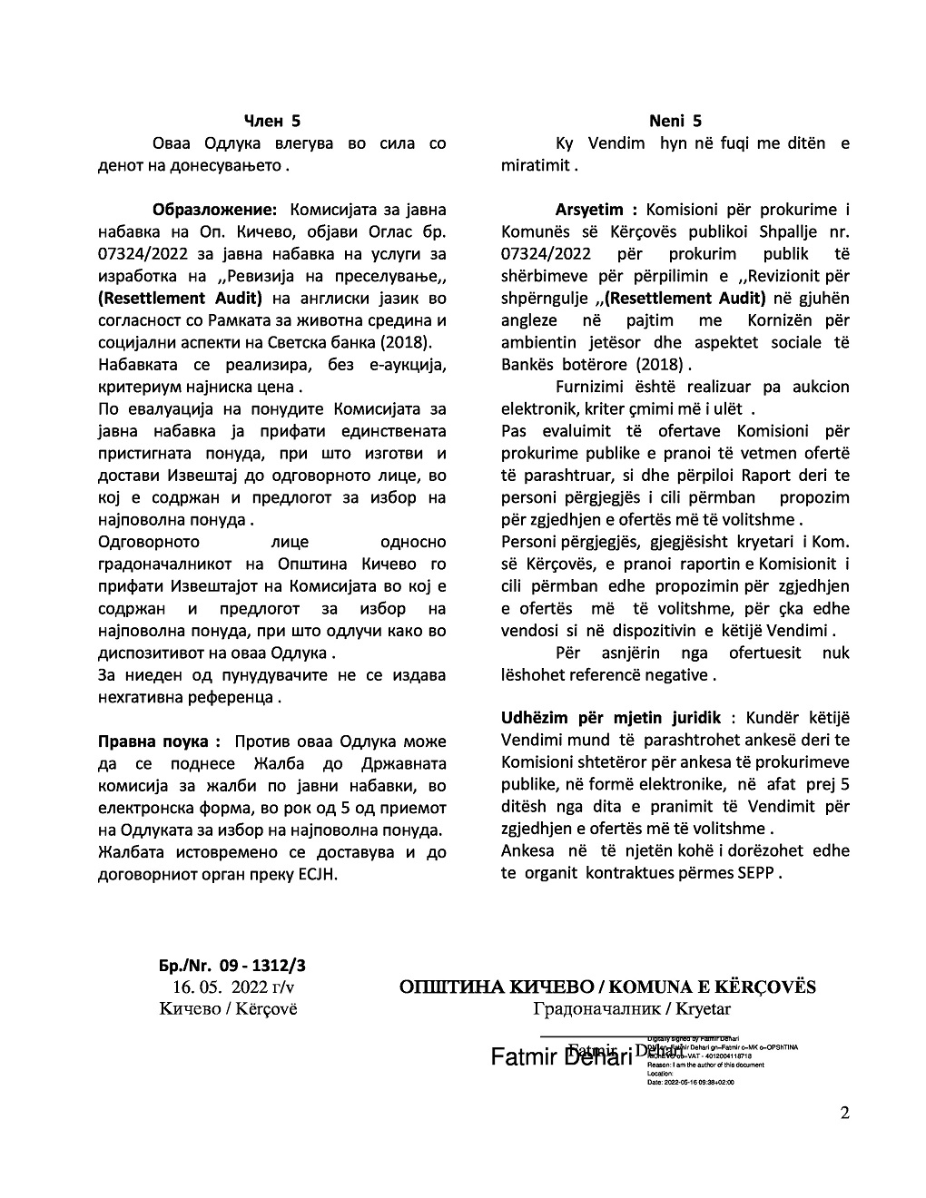

Annex 3: Ascertainment for determining the condition of temporary facilities that do not perform activities

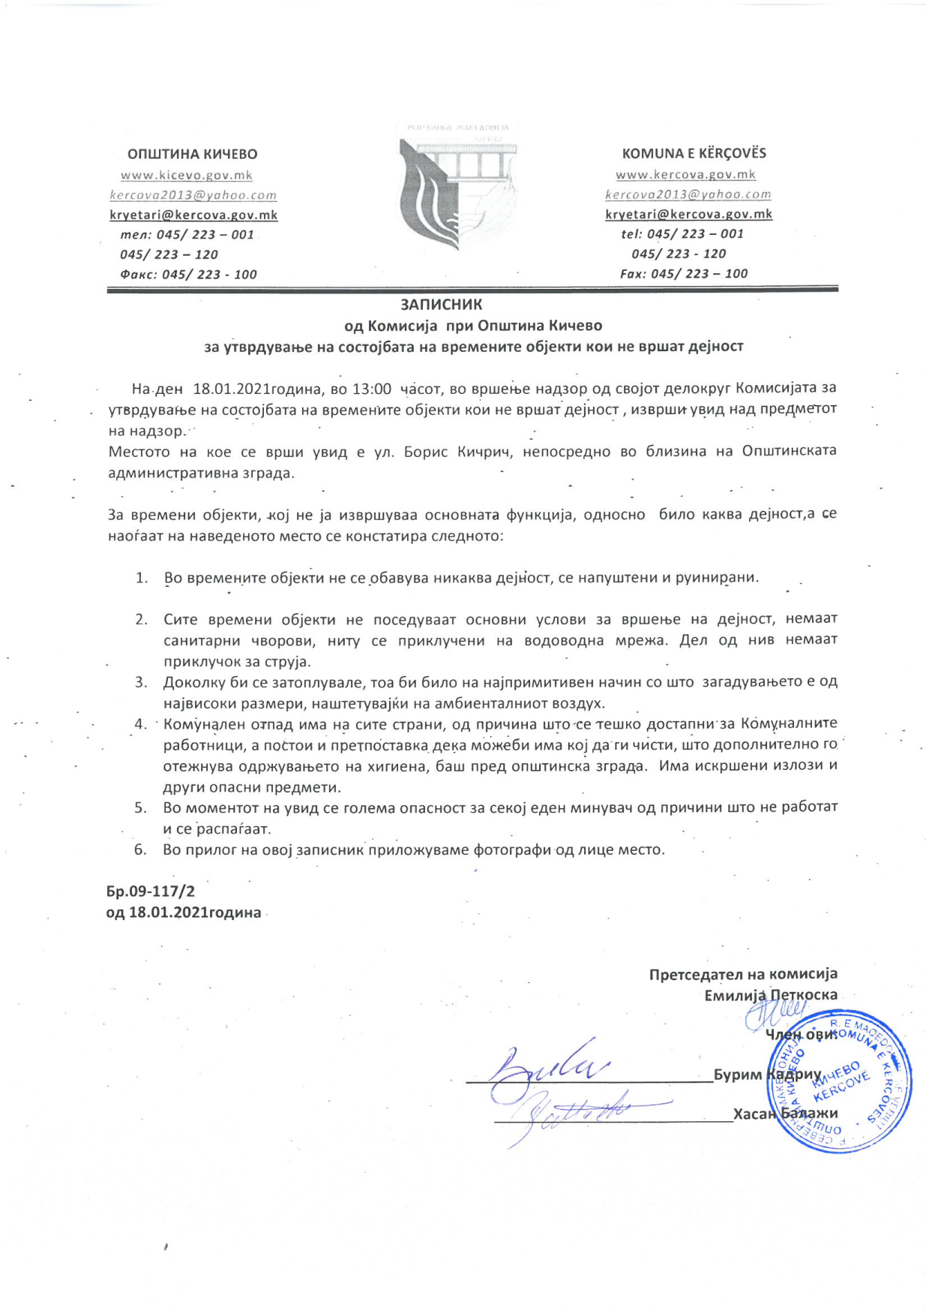

Annex 4: List of online sources of relevant information for this RA

- Се отстрануваат привремени објекти пред општинската зграда во Кичево.
ВЕЧЕР - 21/07/2021, 16:45.

- Над еден милион евра за два капитални проекти.
НОВА МАКЕДОНИЈА - 28.07.2020, 11:10

- Се отстрануваат привремени објекти пред општинската зграда во Кичево.
МИА - 21 јули 2021, 16:11

- Отстранети времените објекти пред општинската зграда во Кичево.
МИА - 26 јули 2021, 22:05

- Ќе се отстранат времените објекти пред ОУ„ Кузман Јосифоски-Питу“ во Кичево.
МИА - 30 јули 2021, 20:07

- Се отстрануваат времените објекти пред училиштето „Кузман Јосифовски-Питу“ во Кичево
МИА - 29 август 2021, 14:15

- Привршува отстранувањето на времените објекти од улицата „Борис Кидрич“
МИА - 20 октомври 2021, 12:23

- Отстранети времените објекти пред општинската зграда во Кичево
ВЕЧЕР - 26/07/2021, 22:51

Annex 5: Agreement/Consent to be offered by the Municipality for compensation of affected parties

C O N S E N T
I, ________________________________________, identified with Unique Registered Citizen’s Number _______________________, agree to accept compensation (disbursed on my transaction account) for incurred costs due to displacement from the Boris Kidrich Street, where I had _________________________________ (explain the type of) business:
No. | Costs for | MKD
TOTAL AMOUNT:

At the same time, I declare that I have no other claims from the Municipality of Kichevo in regards of displacement of my business from the Boris Kidrich Street, and I give my consent to be contacted by the parties involved in financing of the Project for rehabilitation of the Boris Kidrich Street.

Name, Surname and Signature Date
_____________________________ _____________________________

С О Г Л А С Н О С Т
Јас ________________________________________, со ЕМБГ _______________________ се согласувам Општина Кичево да ми исплати на трансакциска сметка компензација за настанатите трошоци по основ на дислокација од улица Борис Кидрич, каде што имав бизнис ________________________________________ (краток опис):
Бр. | Трошок | МКД

Воедно, изјавувам дека немам други побарувања од Општина Кичево по основ на преселување на бизнисот од улица Борис Кидрич и согласен/-на сум да ме контактираат страни кои се вклучени во финансирање на Проектот за рехабилитација на улицата Борис Кидрич.

Име, презиме и потпис Датум
_____________________________ _____________________________

Annex 6: Grievance Redress Form

Reference No:
Full Name and Surname:
(you can remain anonymous if you prefer or request not to disclose your identity to the third parties without your consent)
Contact information:  Please mark how you wish to be contacted (mail, telephone, e-mail) | - By Post: Please provide postal address  _________________________________________________  _________________________________________________  - By phone: ________________________________________  - By e-mail:
Preferred language of communication: | Macedonian  Albanian  Other:
Description of incident/grievance: What happened? Where did it happen? Who did it happen to? What is the result of the problem?

Date of incident/grievance: | One-time incident/grievance (date ____________ )  Happened more than once/how many times? (______)  On-going/currently experiencing problem
What would you like to see happen to resolve the problem?
Signature: |  | Date:
Please return this form to:  PIU of LRCP  Ms. Harita Pandovska  email: harita.pandovska@mtc.gov.mk  tel. + 389 (0)2 3145-497  Ministry of Transport and Communications  Dame Gruev Str. 6,  1000 Skopje, RN Macedonia |  | Municipality of Kichevo  Mr. Burim Kadriu  Boris Kidrich Street  Kichevo  R. North Macedonia

Annex 7: List of contact information of the affected individuals
PAP's code | Name and Surname of PAP | Status | Phone
P01
P02
P03
P04
P05
P06
P07
P08
P09
P10
P11
P12
P13
P14
P15
P16
P17
P18
P19
P20
P21
P22
P23
P24
P25

Annex 8: Image of dislocation of object 5 by the company owner

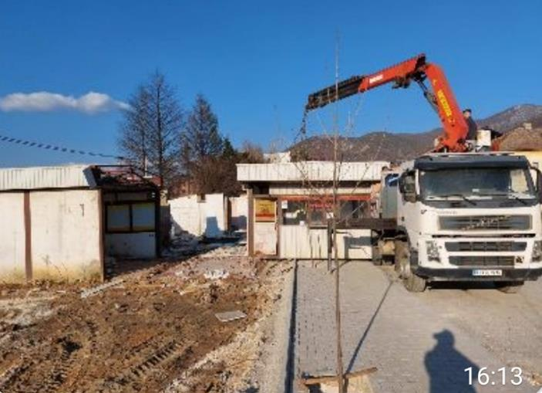

Annex 9: Image of new location of object 8

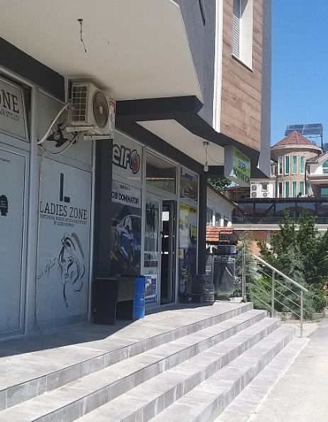

https://kicevo.gov.mk/mk/mekanizmi-i-ankesave-dhe-parashtresave/
https://kicevo.gov.mk/mk/world-bank-njoftim/

